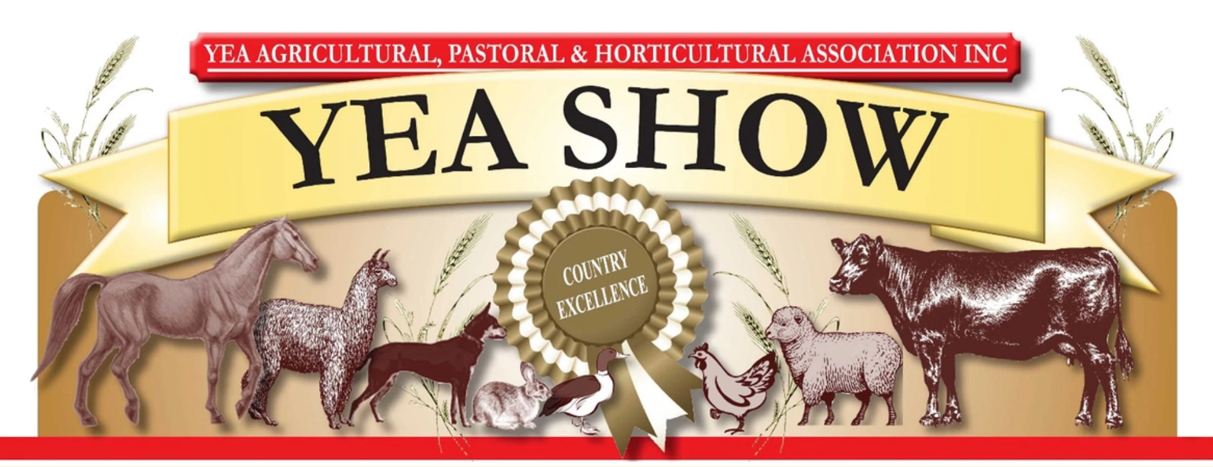
Yea Show Trade
STALLHOLDER FORM
- Stall holders must be set up by 9am and all vehicles removed if they don't fit behind your site
- Insurance: All exhibitors are responsible for any claim/s arising as a result of any damage or injury of any description which may occur to person or property or be occasioned by or arise out of the use of any machinery, implement or apparatus of any nature used in connection with, or caused directly by the carrying out of exhibitors’ business or activity at the Show. The Yea A.P. & H. Association is indemnified against any such claims.All Trade Exhibitors are required (in their own interest) to ensure they have current Public Liability Insurance cover of at least AUD $10,000,000. Proof of adequate Public Liability Insurance must be provided when lodging application. (Please attach copy) NO PROOF, NO SITE
STALLHOLDER DETAILS
Name:
Company/Business Name:
Address:
Email:
Phone: |  |  |  | Mobile:
Website:
Facebook page:
Instagram page:
DESCRIPTION OF ITEMS FOR SALE – PLEASE SELECT AT LEAST ONE CATEGORY
Ceramics/Glass | Clothing/Textiles |  |  |  | Wood/Metal |  |  | Upcycled
Sculpture | Beauty Products |  |  |  | Paper Goods, Cards etc |  |  | Home Decor
Jewellery | Food |  |  |  | Other:
Please note: All food and beverage providers at the show must be registered with FoodTrader and submit a statement of trade through FoodTrader for the show.
To assist with promotion, briefly describe the products that you wish to sell at the Yea show including details on design and/or the production of your products.
Please include at least TWO photos of your products.
SET UP DETAILS – SELECT OPTIONS
Standard stall $30  3m x 3m |  | Double stall $40  6m x 3m |  |  |  |  | Other: (cost TBA, dependent on size)
Do You Require Power? Yes No
Please Note: All electrical leads and appliances need to be tagged and tested.
Will you be using a portable gas cylinder/s? Yes. No
If Yes, how many portable gas cylinders will you have?
Please Note: All gas cylinders must be 10 years old or less from their test date stamp. A small fire extinguisher must be available for any equipment or appliance with a naked flame.
Do you Hold a Public Liability Policy |  |  | Yes  (If yes, please supply a copy of your certificate of currency) |  |  |  |  |  | No
Stall Holders are required to pre-pay their site fees prior to the Market. Site fees are due by Thursday 23rd at 8pm
Payment can be made via direct deposit as follows: Account Number :147034698
BSB: 633-000
(Please use your Business Name as the reference when making the payment.)
A receipt will be issued after payment is made and gate passes will be sent out.
SIGNATORY DETAILS
Name |  |  |  |  |  | Dated
Signature
If you require further details about the Yea Show or this form, please contact:
Kimm on 0477972545 or info@yeashow.org.au (please leave a message or send a text, if either are unavailable).
Notes to prospective stall holders: ● Please make sure your contact details are correct.
- Stallholders are required to provide their own tables and chairs, marquee/gazebo. Weights must be used on all gazebos.
- Please note that there are no ‘cash out’ EFTPOS facilities at this event.
- Unless by prior arrangement, pack up time will be from 5pm. As there will still be many people in the vicinity care must be taken during pack up.
- Please note that once you have been confirmed as a stallholder and you have paid your site fee, no refund will be made in the event that you cancel your site.

