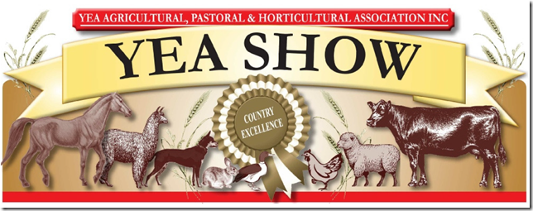

Platinum Sponsorship $2000 and above
As a Platinum Sponsor, you will be recognised in the following ways:
- Company/Business promotion over the public address throughout Show Day (company information to be provided to the committee)
- Four passes to a sit down two-course luncheon on Saturday in the Pavilion.
- Naming rights to a non-sponsored championship within any section.
- Full-page advertisement in the Yea Show printed schedule, company logo on the Yea Agricultural, Pastoral and Horticultural Association website and on the electronic display on Show Day
- Opportunity to display company signage, goods or services at the Yea Show.
- Opportunity to present trophies, ribbons or sashes.
- Complimentary entry for 10 people to the Friday night Heifer Challenge and the Show on Saturday.
- Certificate of acknowledgement for sponsorship.

Gold Sponsorship $1000
As a Gold Sponsor, you will be recognised in the following ways:
- Full-page advertisement in the Yea Show printed schedule, company logo on the Yea Agricultural, Pastoral and Horticultural Association website
- Opportunity to display company signage, goods or services at the Yea Show.
- Opportunity to present trophies, ribbons or sashes.
- Complimentary entry for 6 people to the Friday night Heifer Challenge and the Show on Saturday.
- Certificate of acknowledgement for sponsorship.

Silver Sponsorship $500
As a Silver Sponsor you will be recognised in the following ways:
- Half-page advertisement in the Yea Show printed schedule, company logo on the Yea Agricultural, Pastoral and Horticultural Association website
- Opportunity to display company signage, goods or services at the Yea Show.
- Opportunity to present trophies, ribbons or sashes.
- Complimentary entry for 4 people to the Friday night Heifer Challenge and the Show on Saturday.
- Certificate of acknowledgement for sponsorship.
Bronze Sponsorship $200
As a Bronze Sponsor you will be recognised in the following ways:
- Quarter-page advertisement in the Yea Show printed schedule, company logo on the Yea Agricultural, Pastoral and Horticultural Association website
- Opportunity to display company signage, goods or services at the Yea Show.
- Complimentary entry for 2 people to the Friday night Heifer Challenge and the Show on Saturday.
- Certificate of acknowledgement for sponsorship.

Sponsorship Acceptance

Business Name:
Contact Name:
Address:

Email:
Telephone:
Sponsorship Contribution:$
Preferred Show Section:
(ie Horse, Woodchop, Cattle, Art/Craft etc)

For your advertisement to be include in the Schedule or your logo on the website your artwork must be submitted by 15th September

Please find attached cheque payable to
Yea A,P & H. Assoc. Inc., PO Box 201, YEA 3717.

``` Direct Bank Deposit Details: Yea Community Bank (Bendigo Bank) BSB. 633-000
Account No: 147034698 (Please enter Sponsor and Name as reference)

